Title

Heading
To take advantage of this template’s design, use the Styles gallery on the Home tab. You can format your headings by using heading styles, or highlight important text using other styles, like Emphasis and Intense Quote. These styles come in formatted to look great and work together to help communicate your ideas.
Go ahead and get started.

Some Terms
The following is at best a rough draft.
These kinds of money apply at the individual bank level and at the international level:
currency deposit. The old fashioned demand deposit which can be withdrawn at any time for physical cash. Internationally, think “currency controls”; locally, think “a bank run at my bank”.
demand deposit. money which now has attributes assigned by the bank itself and by the government concerning how much of the deposit may be rehypothecated.
hot money. money deemed risky (not suitable for rehypothecation) by regulators. It is likely to be withdrawn or transferred to another bank
- in a time of financial crisis,
- when a financial sea change offers a better opportunity than simply waiting for a better opportunity,
- when the current bank is seen as failing (your typical bank run), or
- when the FX prospects seem seriously adverse.
It also is likely to involve a concomitant forex transaction affecting central bank books.

Big Banks to America’s Firms: We Don’t Want Your Cash
From: http://www.wsj.com/articles/big-banks-to-americas-companies-we-dont-want-your-cash-1445161083
Oct. 18, 2015 5:38 a.m. ET

U.S. banks are going to new lengths to ward off a surprising threat to their financial health: big cash deposits.
State Street Corp., the Boston bank that manages assets for institutional investors, for the first time has begun charging some customers for large dollar deposits, people familiar with the matter said. J.P. Morgan Chase & Co., the nation’s largest bank by assets, has cut unwanted deposits by more than $150 billion this year, in part by charging fees.
The developments underscore a deepening conflict over cash. Many businesses have large sums on hand and opportunities to profitably invest it appear scarce. But banks don’t want certain kinds of cash either, judging it costly to keep, and some are imposing fees after jawboning customers to move it.
The banks’ actions are driven by profit-crunching low interest rates and regulations adopted since the financial crisis to gird banks against funding disruptions.
The latest fees center on large sums deemed risky by regulators, sometimes dubbed hot-money deposits thought likely to flee during times of crises. Finalized last September and overseen by the Federal Reserve and other regulators, the rule involving the liquidity coverage ratio forces banks to hold high-quality liquid assets, such as central bank reserves and government debt, to cover projected deposit losses over 30 days. Banks must hold reserves of as much as 40% against certain corporate deposits and as much as 100% against some deposits from hedge funds.
“At some point you wonder whether there will be a shortage of financial institutions willing to take on these balances,” said Kelli Moll, head of Akin Gump Strauss Hauer & Feld LLP’s hedge-fund practice in New York, saying that where to hold cash has become an increasing topic of conversation as hedge funds are shown the door by long-time banking counterparties.
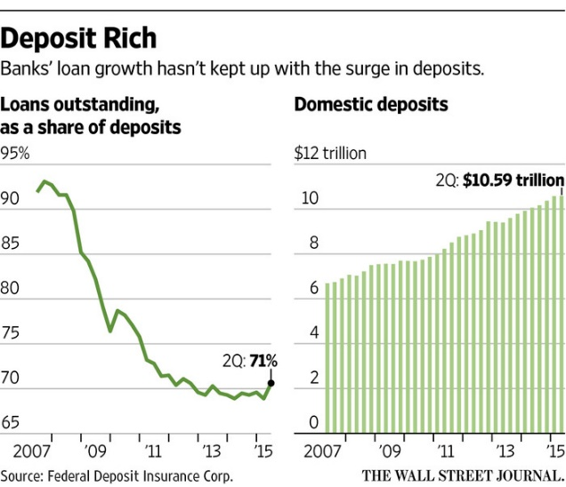ENLARGE
The push comes as the globe is awash in cash, reflecting soft economic growth and low interest rates that limit investment. Some asset managers have been increasing the amount of cash they are holding in their portfolios, in part because of an increased focus by the Securities and Exchange Commission on liquidity management in mutual funds.
Domestic deposits at U.S. banks in the second quarter hit $10.59 trillion, up 38% from five years earlier, Federal Deposit Insurance Corp. data show. Loans outstanding at U.S. banks as a share of total deposits tumbled to 71% from 78% in 2010 and 92% in mid-2007, before the financial crisis, the data show.

Domestic deposits at U.S. banks in the second quarter hit $10.59 trillion, up 38% from five years earlier, Federal Deposit Insurance Corp. data show. Loans outstanding at U.S. banks as a share of total deposits tumbled to 71% from 78% in 2010 and 92% in mid-2007, before the financial crisis, the data show.
Jerome Schneider, head of Pacific Investment Management Co.’s short-term and funding desk, which advises corporate and institutional clients, said that as a result of the bank actions, he and his customers have discussed as cash alternatives boosting investments in U.S. Treasury bonds, ultrashort-duration bond funds and money-market funds.
When it comes to cash, Mr. Schneider said, “Clients have been put on warning.”
Auctions for one- and three-month Treasury bills this week sold bills at zero yields, reflecting outsize demand for the securities.
Few banks disclose how much in “nonoperating” deposits they hold. Credit Suisse GroupAG analysts estimated in August that the top four U.S. banks by assets hold roughly $650 billion in those deposits that require the highest levels of reserves.
Banks are struggling to generate returns for investors. A low-interest rate environment squeezes bank profits by narrowing the spread between the rate they lend at and their borrowing, or funding, cost.
Some analysts have been predicting rates would rebound, likely boosting bank profits, but that hasn’t happened. This year, slowing growth in China and recessions in some major emerging-market nations have dimmed expectations that the Federal Reserve will raise interest rates this year.
The KBW Nasdaq Bank Index of large commercial banks has dropped about 9% since July as rate-increase expectations waned.
Deposit fees are particularly significant at State Street because its primary business is custodying client assets, including holding cash for clients rather than seeking to lend out those funds, as other banks typically do.
State Street customers earlier were told that fees were possible on accounts whose nonoperational balances had grown, the people familiar with the matter said. There is no minimum deposit size that triggers the fee, which varies and is applied case by case to new and existing clients, the people said.
“The persistence of the current rate environment requires that we take action consistent with prudent financial management with certain accounts that continually maintain significant excessive cash balances,” State Street said in a statement to The Wall Street Journal.
BNY Mellon and Northern Trust haven’t yet begun charging to hold clients’ cash, people familiar with the matter said. A Bank of New York spokesman said the bank hasn’t ruled out doing so in the future. The fees at J.P. Morgan don’t apply to clients of its custody business, a person familiar with the bank said.
Northern Trust has been taking a “transaction by transaction approach” to accepting very large deposits from clients approaching the bank, said Chief Financial Officer S. Biff Bowman on the bank’s second-quarter earnings call in July. A Northern Trust spokesman declined to say whether charges were a possibility in the future.
State Street and others have charged clients on some large euro deposits for more than a year, reflecting a negative interest rate on overnight deposits at the European Central Bank.
In 2011, BNY Mellon set plans to charge a small number of clients for holding their cash, reflecting in part a large flow of deposits triggered by investors’ flight to safety that summer. The bank rolled back the plan without imposing fees after some clients pulled money.
Since last year, Bank of America Corp. has told some institutional clients that they will need to move their deposits or pay to keep them at the bank, people familiar with the matter said. Top executives decided to approach clients that didn’t do other business with the bank.
—Christina Rexrode contributed to this article.
Write to Juliet Chung at juliet.chung@wsj.com and Sarah Krouse atsarah.krouse@wsj.com

